

NATIONAL INSTITUTE OF TECHNOLOGY KARNATAKA

SURATHKAL, MANGALORE - 575 025

Course Code – CS111

Course Name – Computer Programming Lab

Lab - 03

Date – May 25, 2021

Submitted To

Marwa Mohiddin Ma’am

Department of Computer Science and Engineering

National Institute of Technology Karnataka, Surathkal

Submitted By

Md Rakib Hasan

Roll – 201CS132

Department of Computer Science and Engineering

**Decision making- and Branching constructs**

**Question – 1**

To determine whether a character entered is in lowercase, uppercase, digit or a special character

**Answer**

#include<stdio.h>

int main()

{

    char ch;

    printf("Enter character: ");

    scanf("%c",&ch);

    if((ch>='0') && (ch<='9'))   // number

    {

        printf("\nDigit\n");

    }

    else if ((ch>='a')&&(ch<='z'))   //lowercase

    {

        printf("\nLowercase\n");

    }

    else if ((ch>='A') && (ch<='Z'))  //uppercase

    {

        printf("\nUppercase\n");

    }

    else                          //otherwise special character

    {

        printf("\nSpecial Character\n");

    }

    return 0;

}

**Output**

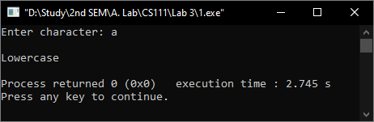

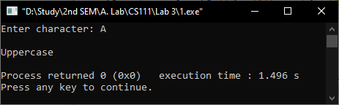

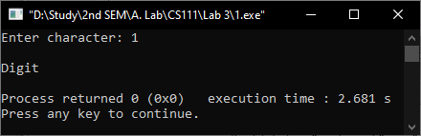

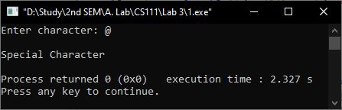

**Question-2**

Find the roots of quadratic equation

**Answer**

#include <stdio.h>

#include <math.h>

int main()

{

    float a, b, c;

    printf("Enter the value of a, b & c: ");

    scanf("%f %f %f", &a, &b, &c);

    if (a != 0)     //a^2 + b + c = 0 so a!=0

    {

        float discriminate, root_1, root_2;

        discriminate = pow(b, 2) - 4 * a * c;

        if (discriminate >= 0)

        {

            root_1 = (-b + sqrt(discriminate)) / (2 * a);

            root_2 = (-b - sqrt(discriminate)) / (2 * a);

            printf("\nValue of x1 = %.2f\n", root_1);

            printf("Value of x2 = %.2f\n", root_2);

        }

        else

        {

            float real, imaginary;

            real = (-b) / (2 * a);

            imaginary = (sqrt(-(discriminate))) / (2 * a);

            printf("\nRoot 1 = %.2f + (%.2fi)\n", real, imaginary);

            printf("Root 2 = %.2f - (%.2fi)\n", real, imaginary);

        }

    }

    return 0;

}

**Output**

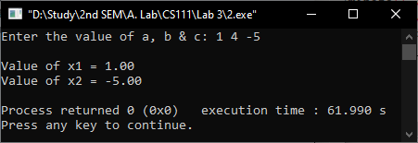

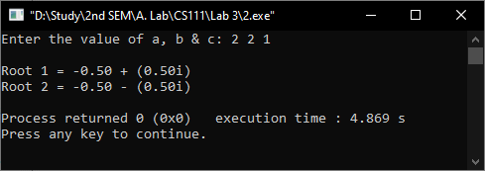

**Question – 3**

Write a menu driven program to demonstrate the simple arithmetic calculator

**Answer**

#include<stdio.h>

int main()

{

    float num1, num2;

    printf("Enter two number: ");

    scanf("%f %f", &num1, &num2);

    printf("\nMenu\n");

    printf("1. Addition\n");

    printf("2. Subtraction\n");

    printf("3. Multiplication\n");

    printf("4. Division\n");

    printf("5. Close\n");

    int choice;

    printf("Enter your choice: ");

    scanf("%d",&choice);

    float result;

    switch(choice)

    {

    case 1:

        result = num1 + num2;

        break;

    case 2:

        result = num1 - num2;

        break;

    case 3:

        result = num1 * num2;

        break;

    case 4:

        result = num1 / num2;

        break;

    case 5:

        printf("\nClosed\n");

        return 0;

    default:

        printf("\nInvalid Input\n");

        return 0;

    }

    printf("\nResult = %.2f\n",result);

    return 0;

}

**Output**

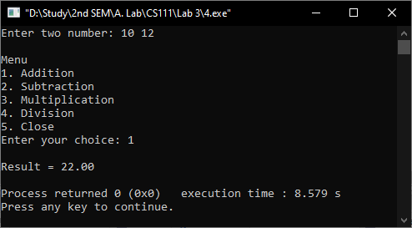

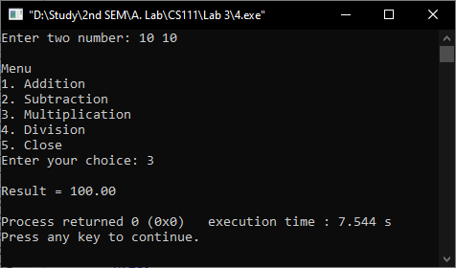

**Decision making and looping constructs**

**Question – 1**

Program to reverse the digits of a number and to find the sum of the digits

**Answer**

#include<stdio.h>

int main()

{

    int num;

    printf("Enter a number: ");

    scanf("%d", &num);

    int remainder, sum=0, reverse=0;

    while (num != 0)

    {

        remainder = num % 10; //separate last digit

        sum += remainder;     //add

        reverse = reverse*10 + remainder;  //reverse

        num /= 10;

    }

    printf("\nSum of the digits = %d\n",sum);

    printf("Reverse number = %d\n",reverse);

    return 0;

}

**Output**

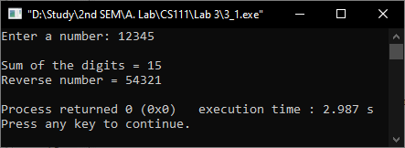

**Question-2**

Program to find factors of a given number

**Answer**

#include<stdio.h>

int main()

{

    int num;

    printf("Enter a number: ");

    scanf("%d",&num);

    printf("Factors of %d = ",num);

    int i;

    for(i=1; i<=num; i++)

    {

        if(i==num)

        {

            printf("%d",i); //remove comma after last factor

        }

        else if (num%i==0)

        {

            printf("%d, ",i);

        }

    }

    return 0;

}

**Output**

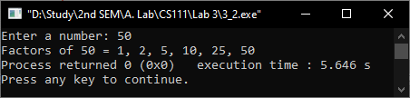

**Question-3**

Program to find the prime and non-prime numbers between a given range

**Answer**

#include<stdio.h>

int main()

{

    int lower, upper, i, j, k=0, z=0, len, num, prime_num;

    printf("Enter the lower and upper bound: ");

    scanf("%d %d", &lower, &upper);

    len = (upper - lower)-1;          //total number between upper and lower

    int prime[len], not_prime[len];

    num = lower+1;

    for(i=0; i<len; i++)

    {

        if(num<2)

        {

            num = 2;       //lowest prime number is 2

            continue;

        }

        prime_num = 1;      //prime number? 1 means yes

        for(j=2; j<num; j++)

        {

            if(num % j == 0)

            {

                prime_num = 0;   // prime number? 0 means false

                break;

            }

        }

        if(prime_num == 0)

        {

            not_prime[z] = num;  // storing non-prime in an array

            z++;

        }

        else

        {

            prime[k] = num;   //storing prime in an array

            k++;

        }

        num++;

    }

    printf("Prime = ");

    for(i=0; i<k; i++)

    {

        printf("%d ",prime[i]);

    }

    printf("\nNot prime = ");

    for(i=0; i<z; i++)

    {

        printf("%d ",not_prime[i]);

    }

    return 0;

}

**Output**

